# Problem 2 – Monkey in the Jungle

You are given an unresponsive website (**HTML + CSS + images**). Your task is to make the site responsive.

The site layout should change according to the browser viewport / screen size. You need to implement 1 layout: **width <= 480px**. The figures below represents this layout:

 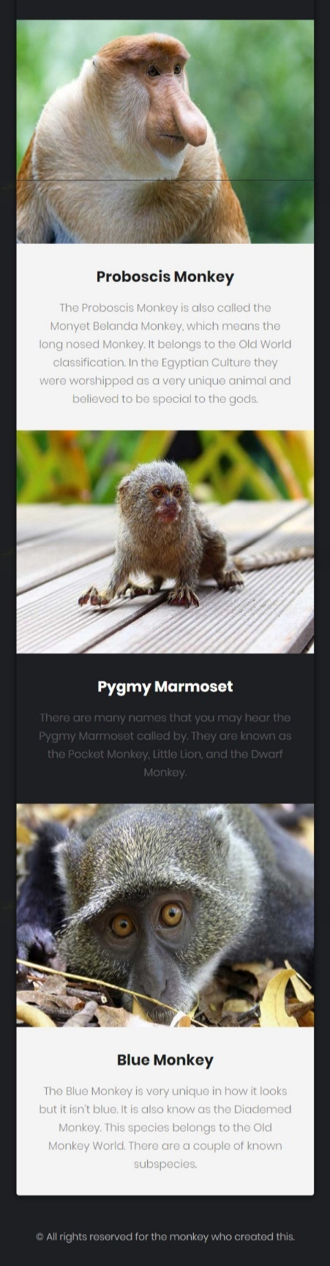

## Output

The output should be valid **HTML** + **CSS** + **images** that implement the above responsive site.

## Constraints

* You are **NOT** permitted to change the **HTML**
* You are **NOT** permitted to use libraries like Bootstrap
* Pixel-perfect implementation is **NOT** required
* The site should open correctly in the latest version of Chrome